Unit 3 – Lesson 3. Data relations and SQL Joins
Aim:
- What is SQL and what are some of the most commonly used SQL commands?
- How do we write a simple SQL query to construct a table, query a table and display the result?

Objectives: After the lesson, students will be able to:
- Obtain basic understanding of SQL query and SQL command
- Use Oracle Live SQL to create simple SQL scripts

CLASS PROCEDURE:

Do Now: Consider the following data table. Discuss with your partner and answer the questions.

Name | Address | Date of Birth | Salary
Jim Smith | 1 Apple Lane | 1/3/1991 | 11000
Jon Greg | 5 Pear St | 7/9/1992 | 13000
Bob Roberts | 2 Plumb Road | 3/2/1990 | 12000

- Write a SQL statement to display the name, data of birth and salary for the employee(s) whose salary is more than 11500.

- * Write a SQL statement to display the name, data of birth and salary for the employee(s) whose first name starts with letter “J”. [You may use the reference table or search online to find the answer]

- What is the “schema’ referred to in Oracle Live SQL? Describe the schema of the given data table.

- What is “data” referring to in Oracle Live SQL? Describe the data provided by the given table.

Class Discussions on RDBMS:
- The database systems we study now are also called the relational database management systems, or often referred to as RDBMS. RDBMS data is structured in database tables, fields and records. Each RDBMS table consists of database table rows. Each database table row consists of one or more database table fields.

- RDBMS store the data into collection of tables, which might be related by common fields (database table columns). RDBMS also provide relational operators to manipulate the data stored into the database tables. Most RDBMS use SQL as database query language.

- Here’s an example of a RDBMS data model:

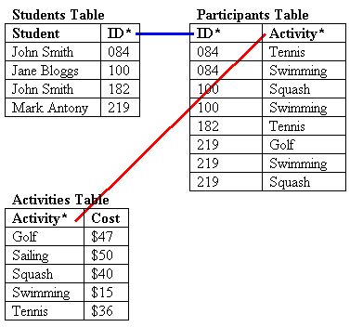

Pair – sharing Discussion / Class Discussion on data models:
Discuss with your partner and find examples of relational data that match the following described relational models, and discuss on how can we use SQL to “link” and present the data records.

- One – to – one:

- Many – to – one:

- One – to – many:

- Many – to – many:

Presentation – the four different kinds of JOIN in SQL:

- INNER JOIN (OR JOIN): Returns all rows when there is at least one match in BOTH tables
Example:
SELECT column_name(s)
FROM table1
JOIN table2
ON table1.column_name=table2.column_name;
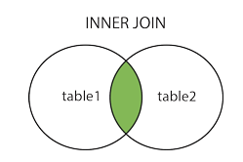

- LEFT JOIN: Return all rows from the left table, and the matched rows from the right table
SELECT column_name(s)
FROM table1
LEFT JOIN table2
ON table1.column_name=table2.column_name;
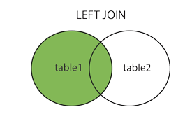
- RIGHT JOIN: Return all rows from the right table, and the matched rows from the left table
SELECT column_name(s)
FROM table1
RIGHT JOIN table2
ON table1.column_name=table2.column_name;
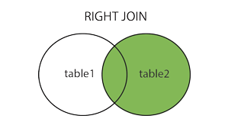

- FULL JOIN: Return all rows when there is a match in ONE of the tables
SELECT column_name(s)
FROM table1
FULL OUTER JOIN table2
ON table1.column_name=table2.column_name;
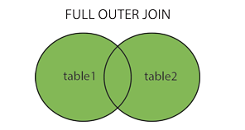

Lab / Pair – sharing Practice: Exploring different SQL joins

- Let’s go to Oracle Live SQL, go to the SQL worksheet, first create a STUDENT1 table and insert some dummy records:

CREATE TABLE STUDENTS1
(
OSIS varchar(4),
LastName varchar(255),
FirstName varchar(255),
Address varchar(255),
City varchar(255)
);

INSERT INTO STUDENTS1 (OSIS, LastName, FirstName, Address, City)
VALUES ('0001', 'Lee', 'Richard', '1 Oak Street', 'White City');

INSERT INTO STUDENTS1 (OSIS, LastName, FirstName, Address, City)
VALUES ('0002', 'Young', 'Bob', '2 Apple Street', 'Gray City');

INSERT INTO STUDENTS1 (OSIS, LastName, FirstName, Address, City)
VALUES ('0003', 'Smith', 'John', '10 Watermellon Street', 'Black City');

INSERT INTO STUDENTS1 (OSIS, LastName, FirstName, Address, City)
VALUES ('0004', 'Dee', 'Susan', '10 Strawberry Street', 'Red City'));

SELECT * FROM STUDENTS1;

- Create another table courses and enter some dummy records:

CREATE TABLE COURSES
(
CID varchar(4),
NAME varchar(255),
SECTION varchar(2),
TEACHER varchar(255),
ROOM varchar(10)
);

INSERT INTO COURSES (CID, NAME, SECTION, TEACHER, ROOM)
VALUES ('0011', 'ALGEBRA1', '01', 'Ms. A', '101');

INSERT INTO COURSES (CID, NAME, SECTION, TEACHER, ROOM)
VALUES ('0011', 'ALGEBRA1', '02', 'Ms. A', '101');

INSERT INTO COURSES (CID, NAME, SECTION, TEACHER, ROOM)
VALUES ('0012', 'ALGEBRA2', '01', 'Ms. B', '103');

INSERT INTO COURSES (CID, NAME, SECTION, TEACHER, ROOM)
VALUES ('0012', 'ALGEBRA2', '02', 'Ms. B', '103');

INSERT INTO COURSES (CID, NAME, SECTION, TEACHER, ROOM)
VALUES ('0014', 'GEOMETRY', '01', 'Ms. C', '105');

INSERT INTO COURSES (CID, NAME, SECTION, TEACHER, ROOM)
VALUES ('0014', 'GEOMETRY', '02', 'Ms. C', '105');

INSERT INTO COURSES (CID, NAME, SECTION, TEACHER, ROOM)
VALUES ('0014', 'GEOMETRY', '03', 'Ms. C', '105');

SELECT * FROM COURSES;

- Now create a 3rd table to build the connections between the 1st and the 3rd table, and you and your partner need to write the SQL statements to create the table STUDENT_COURSE, and to insert records so that:

- Lee, Richard will enroll to Algebra1, Section 02 and Geometry, Section 03

- Smith, John will enroll into Algebra2, Section 01

- Dee, Susan will enroll into Algebra 1, Section 01 and Geometry Section 03

- Write a query to display the following information:

Student Last Name, First Name, Course, Teacher, Room

- Write a query to display all of the students who will enroll in Ms. C’s classes this year and show the following information:

Student Last Name, Student First Name, Course Section, Class Room, Student Address, Student City

